# **TOTAL MARKS:50 DURATION: 2 HOURS**

**General Instructions:**

1. *Students are not required to create tables/schema for any question.*
2. *Students may create tables if it helps them solve the problem, but marks are allocated only for the queries.*
3. *Students are required to follow the exact same nomenclature provided in the ER/Table Design Schema including Table Name, Column Name and any Constraints.*
4. *Please follow the same order as in question paper for answering questions.*

**SECTION A: 5 MARKS**

1. State the difference between a Candidate key and Alternate key. **(2 Marks) (Descriptive)**
2. Explain the usage of a group by and a having clause. Mention the rules to be followed while using these clauses. **(3 Marks) (Descriptive)**

**SECTION B: 20 MARKS**

**Refer the Clothing database ER diagram to answer the below questions.**

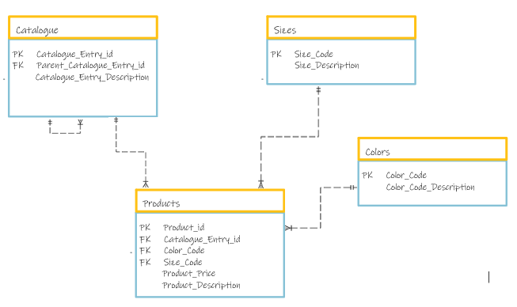

**Table Description:**

**Catalogue**

Catalogue_Entry_id - Catalogue entry id

Parent_Catelogue_Entry_id - Parent catalogue id of sub items that are listed

Catalogue_Entry_Description - description of the entry

**Sizes**

Size_Code - size code

Size_Description - description of the size

**Colors**

Color_Code - color code

Color_Code_Description - description of the color

**Products**

Product_id - id of the product

Catalougue_Entry_id - entry id in the catalogue

Color_Code - color code of the product

Size_Code - size code of the product

Product_Price - price of the product

Product_Description - description of the product

1. On account of monsoon sale, the shop is giving a flat 5% discount for all the Women Sportswear. Get the list of all the products, old price and new price after applying the discount. **(7 marks) (Use tables: - Catalogue, sizes, colors, products)**
2. Get the list of all the catalogue descriptions where the average price of all its products is greater than 1000. **(7 marks) (Use tables: - Catalogue, sizes, colors, products)**
3. Find the number of products available in each ‘size’**. (6 marks) (Use tables: - Catalogue, sizes, colors, products)**

**SECTION C: 25 MARKS**

**Refer the Clothing database ER diagram to answer the below questions.**



**Table Description:**

**Catalogue**

Catalogue_Entry_id - Catalogue entry id

Parent_Catelogue_Entry_id - Parent catalogue id of sub items that are listed

Catalogue_Entry_Description - description of the entry

**Sizes**

Size_Code - size code

Size_Description - description of the size

**Colors**

Color_Code - color code

Color_Code_Description - description of the color

**Products**

Product_id - id of the product

Catalougue_Entry_id - entry id in the catalogue

Color_Code - color code of the product

Size_Code - size code of the product

Product_Price - price of the product

Product_Description - description of the product

1. Fetch the complete details about the products, Catalogue_Entry_Descriptions, sizes, and colors available for the products belonging to 'Adidas' brand. **(8 marks) (Use tables: - Catalogue, sizes, colors, products)**

**Refer the Er diagram for the below Question:**

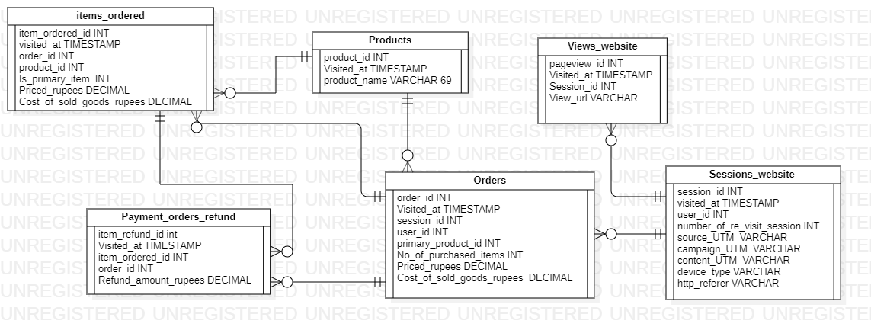

**Traffic source analysis is about understanding where your customers are coming from and which channels are driving the highest quality traffic**

**Table Descriptions:**

**Sessions_website** – provides details about the website visit, time of visit, user who visited and other information

**Orders** – provides information about the orders placed in the websites

**Payment_Orders_Refund –** Provides details about the items which were requested for refund.

**Products_1** - The details of the products present in website

**Items Ordered** – items and the details of the items that were ordered

**Views_Website** – details of the pages viewed in every session.

1. In our website, we have observed that for the Campaign 'nonbrand' the 'gsearch' source drives major traffic. Calculate the session to order Conversion rate in order to understand if these sessions are driving sales?

Note: Conversion rate is calculated as the percentage of number of orders placed as compared to the number of session logins.

**(10 Marks) (Use: - orders, sessions_website tables)**

1. The website business team is analysing the products, which have been returned frequently and customers have requested for a refund. This is help the business to further analyse, and either improvise the quality of the product or discontinue it from the sale. Generate a report that displays the product id, product name and the total number of times a refund was requested for the product. **(7 Marks) (Use tables: - items_ordered, products_1, payment_orders_refund)**